Name: ____________________________ Date: ____________ 8 __ Miss. Celeste
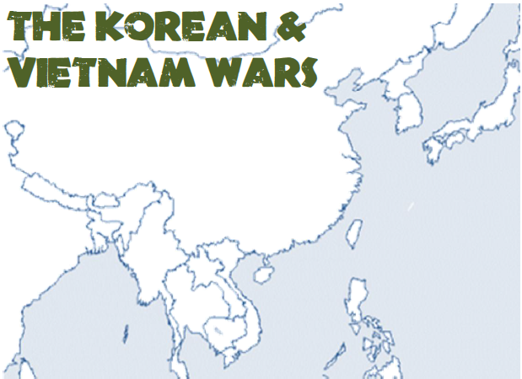
Label the follow on the above map:
Countries: | Laos | N. Korea | Japan | Bodies of Water: |  | Cities:
S. Vietnam | Thailand | S. Korea | Taiwan | Pacific Ocean | Gulf of Tonkin | Hanoi | Saigon
N. Vietnam | Cambodia | China |  | Atlantic Ocean | South China Sea | Pyongyang | Seoul
Other: DMZ & 38th Parallel

Finally, Complete the below chart comparing the two wars with 2-4 facts in each section.
Differences: Korea | Differences: Vietnam
Similarities

